**Experiment -3**

**Implementation of different types of function, operators, Joins with suitable examples.**

**All subsequent examples uses COMPANY database as shown below:**

1. Retrieve the birth date and address of the employee whose name is 'John B.Smith'.

**SYNTAX:**

**select bdate,address from employee where fname="John" and minit="B"and lname="smith";**

**OUTPUT:**

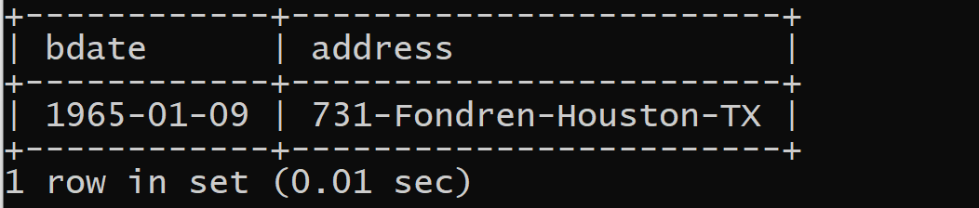

2. Retrieve all employees who were born during the 1950s

**SYNTAX:**

**select fname from employee where bdate like "195%";**

**OUTPUT:**

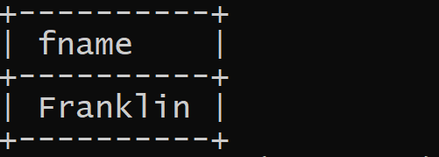

3. Retrieve all employees in department 5 whose salary is between 50,000 and 60,000(inclusive)

**SYNTAX:**

**select fname,salary from employee where dno=5 and (salary>=25000 and salary<=30000);**

**OUTPUT:**

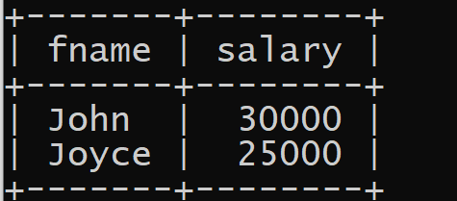

4.Retrieve the names of all employees who do not have supervisors

**SYNTAX:**

**select fname from employee where superssn is null;**

**or**

**select fname from employee e where not exists (select fname from employee a where**

**a.ssn=e.superssn);**

**OUTPUT:**

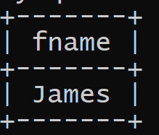

5. Retrieve SSN and department name for all employees

**SYNTAX:**

**select ssn,dname from employee , department where dno=dnumber;**

**OUTPUT:**

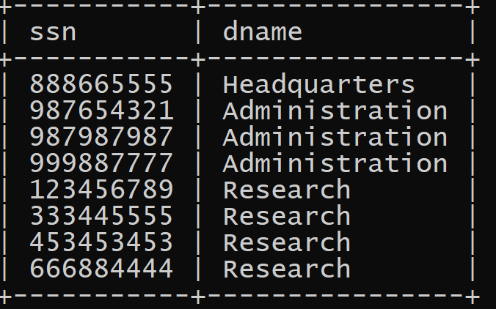

6. Retrieve the name and address of all employees who work for the 'Research' Department

**SYNTAX:**

**select fname,minit,lname from employee,department where dname="research" and**

**department.dnumber=employee.dno;**

**OUTPUT:**

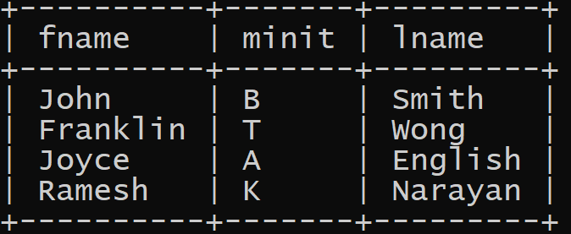

7.For every project located in 'Stafford', list the project number, the controlling department number, and the department manager's last name, address, and birthdate

**SYNTAX**

**select pnumber, dnum, lname, address,bdate from project, department, employee where**

**plocation= “Stafford” and dnum=dnumber and mgrssn=ssn;**

**OUTPUT:**

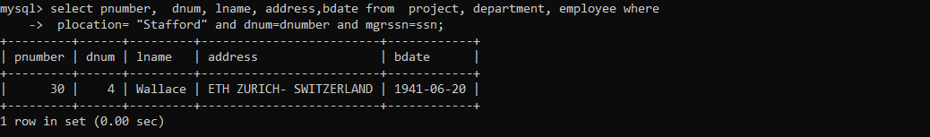

8.For each employee, retrieve the employee's name, and the name of his or her immediate supervisor.

**SYNTAX:**

**select f.fname as employee,e.fname as supervisor from employee e,employee f where e.ssn=f.superssn ;**

**OUTPUT:**

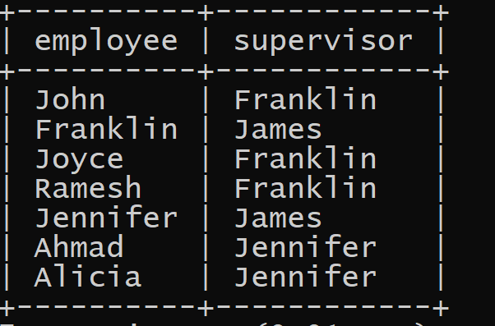

9.Retrieve the name and address of all employees who work for the 'Research'department.

**SYNTAX:**

**select fname,lname,address from employee, department where dname= “Research” and**

**dnumber=dno;**

**OUTPUT:**

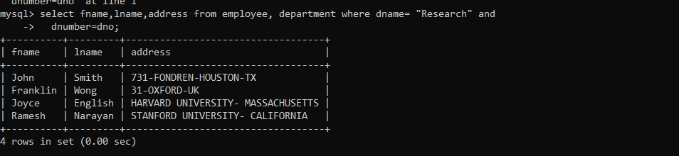

10. For every project located in 'Stafford', list the project number, the controlling department number, and the

department manager's last name, address, and birth date.

**SYNTAX:**

**select pnumber, dnum, lname, bdate, address from project, department, employee where**

**dnum=dnumber and mgrssn=ssn and plocation= “Stafford”;**

**OUTPUT:**

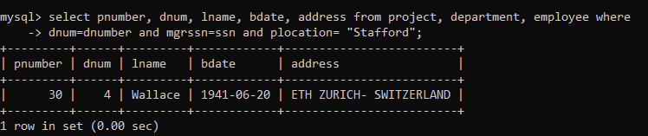

11. Find the maximum salary, the minimum salary, and the average salary among all employees**.**

**SYNTAX:**

**select max(salary), min (salary), avg (salary) from employee;**

**OUTPUT:**

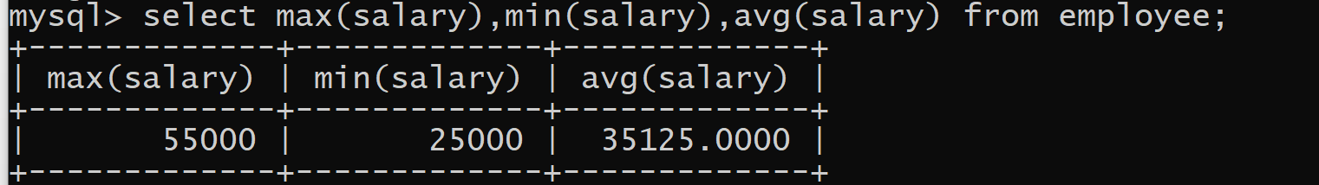

12.Find the maximum salary, the minimum salary, and the average salary among employees who work for

the 'Research' department**.**

**SYNTAX:**

**select max(salary), min(salary), avg(salary) from employee, department where dno=dnumber and**

**dname= “research”;**

**OUTPUT:**

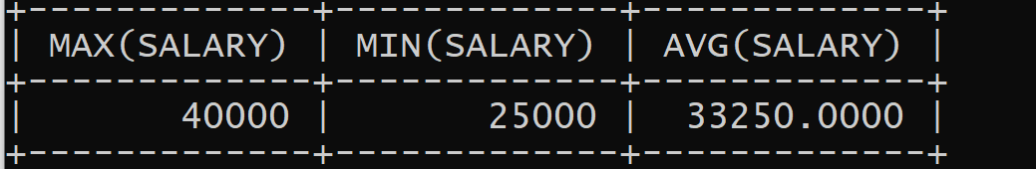

13. Retrieve the total number of employees in the company**.**

**SYNTAX:**

**select count (*) from employee;**

**OUTPUT:**

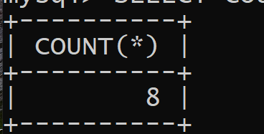

14. Retrieve the number of employees in the 'Research' department

**SYNTAX:**

**select count(*) from employee, department where dno=dnumber and dname=“research”;**

**OUTPUT:**



15.Increase the salary of all employees by 1000 rs.

**SYNTAX:**

**select fname, lname, 1000+salary as increment from employee;**

**OUTPUT:**

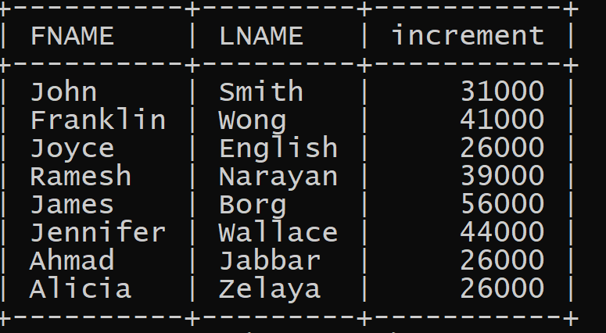

16. Increase the salary of employees who are working on “producty” by 15%**.**

**SYNTAX:**

**select fname, salary+1000 from employee,works_on,project where pname="producty" and**

**pnumber=pno and essn=ssn;**

**OUTPUT:**

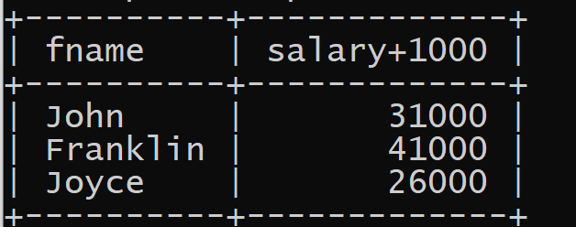

17. Make a list of all project numbers for projects that involve an employee whose last name is 'wong' as a

worker or as a manager of the department that controls the project**.**

**SYNTAX:**

**(select pnumber from project, department, employee where dnum=dnumber and mgrssn=ssn and lname='wong')**

**union**

**(select pnumber from project, works_on, employee where pnumber=pno and essn=ssn and lname='wong');**

**OUTPUT:**

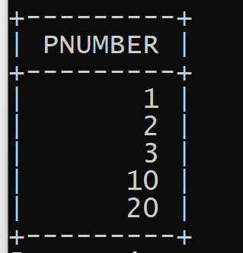

18. Retrieve all employees in department 5 whose salary is between £30,000 and £40,000

**SYNTAX:**

**select * from employee where salary between 30000 and 40000 and dno=5;**

**OUTPUT:**

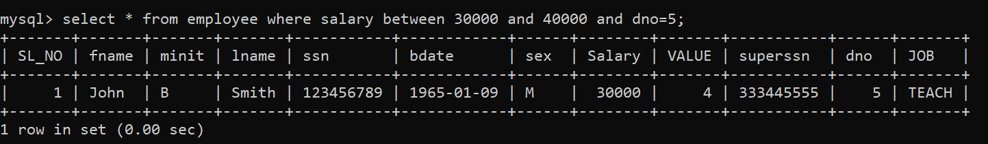

19. Retrieve the number of employees who work for department number 4;

**SYNTAX:**

**select count (*) from employee where dno=4;**

**OUTPUT:**

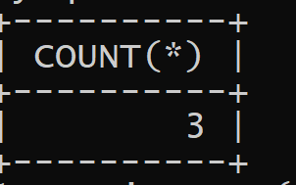

20. For each employee, retrieve the employee's name, and the name of his or her immediate supervisor**.**

**SYNTAX:**

**select e.fname,e.lname,s.fname,s.lname from employee as e ,employee as s where e.superssn=s.ssn;**

**OUTPUT:**

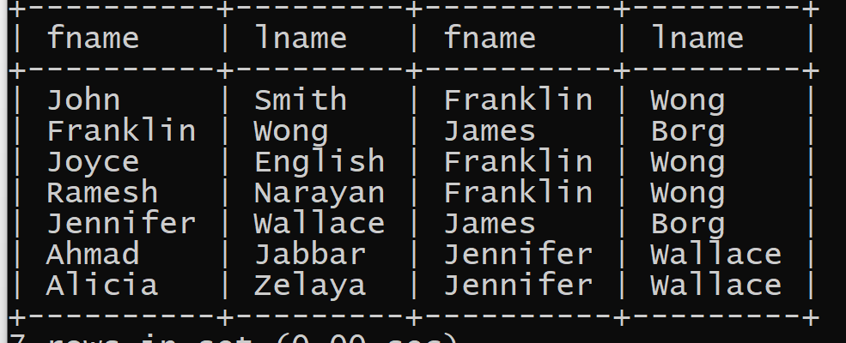

21. Retrieve the SSN and department names of all employees.

**SYNTAX:**

**select ssn, dname from employee, department;**

**OUTPUT:**

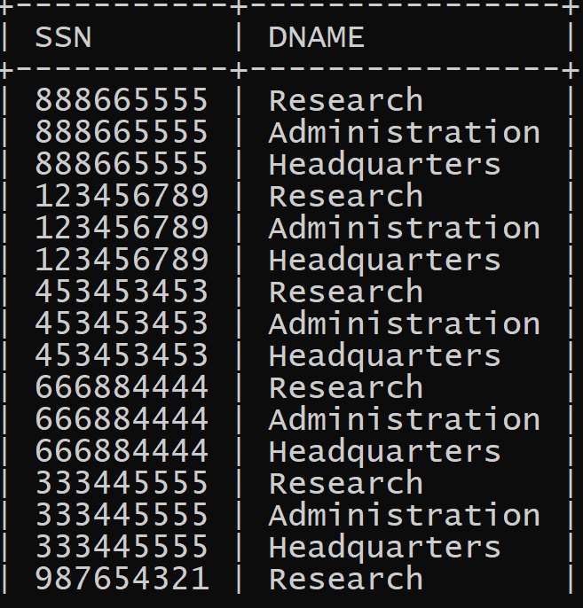

22. Retrieve all the attributes of an employee and attributes of DEPARTMENT he works in for every

employee of ‘Research’ department.

**SYNTAX:**

**select * from employee, department where dname='research' and dno=dnumber;**

**OUTPUT:**

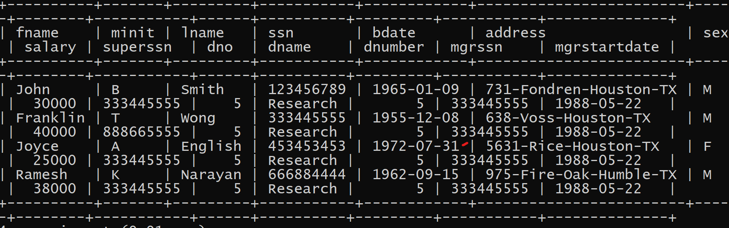

23. Make a list of all project numbers for projects that involve an employee whose last name is 'Smith' as a worker

or as a manager of the department that controls the projec**t.**

**SYNTAX:**

**(select pname from project, department, employee where dnum=dnumber and mgrssn=ssn and**

**lname='smith')**

**union**

**(select pname from project, works_on, employee where pnumber=pno and essn=ssn and**

**lname='smith');**

**OUTPUT:**

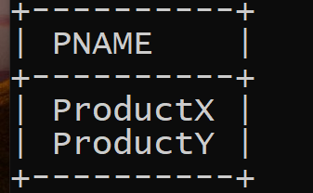

24. Show the effect of giving all employees who work on the 'ProductX' project a 10% raise.

**SYNTAX:**

**select fname, lname, 1.1*salary from employee, works_on, project**

**where ssn=essn and pno=pnumber and pname= “productx”;**

**OUTPUT:**

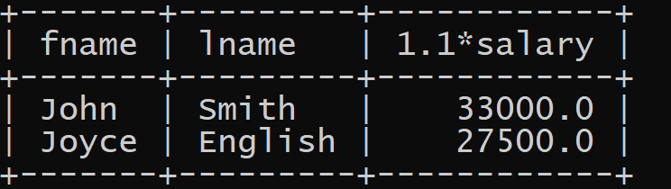

25. Retrieve the name and address of all employees who work for the 'Research' department using nested

query.

**SYNTAX:**

**select fname, lname, address from employee where dno in (select dnumber from department where**

**dname= “research” );**

**OUTPUT:**

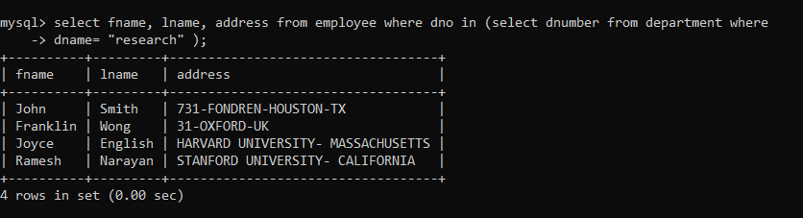

26. Retrieve the name of each employee who has a dependent with the same first name as the employee**.**

**Three ways of writing the query:**

**SYNTAX:**

**select e.fname, e.lname from employee e, dependent d where e.ssn=d.essn and e.fname=d.dependent_name;**

**Using nested query:**

**SYNTAX:**

**select e.fname, e.lname from employee as e where e.ssn in (select essn from dependent where**

**essn=e.ssn and e.fname=dependent_name);**

**Using exists function:**

**SYNTAX:**

**select fname, lname from employee where exists (select * from dependent where ssn=essn and**

**fname=dependent_name);**

**OUTPUT:**



**If empty set is displayed insert the data accordingly and execute.**

Retrieve the names of employees who have no dependents*.*

**SYNTAX:**

**select fname, lname from employee where not exists (select * from dependent where ssn=essn);**

**OUTPUT:**

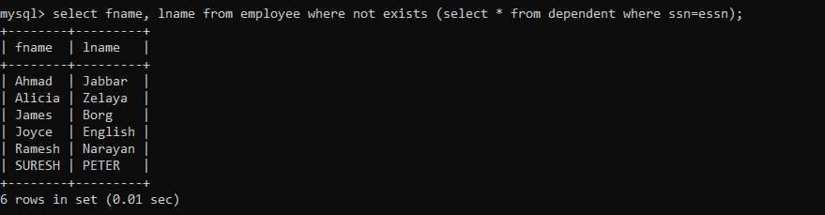

27. Retrieve the social security numbers of all employees who work on project number 1, 2, or 3.

**SYNTAX:**

**select distinct essn from works_on where pno in (1, 2, 3);**

**OUTPUT:**

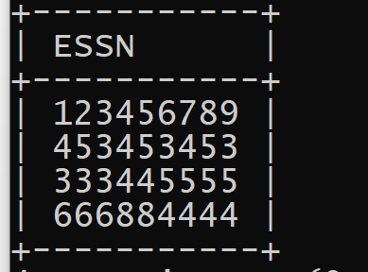

28. Retrieve the names of all employees who do not have supervisors**.**

**SYNTAX:**

**select fname, lname from employee where superssn is null;**

**OUTPUT:**

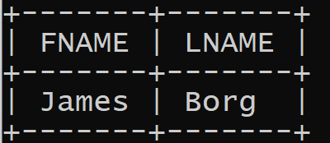

29. Retrieve all employees whose address is in Houston, Texas. Here, the value of the ADDRESS attribute must

contain the substring 'Houston,TX‘ in it.

**SYNTAX:**

**select fname, lname from employee where address like '%houston_tx%';**

**OUTPUT:**

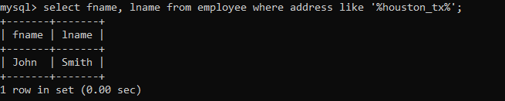

30. Display the names of employees, whose salary is greater than the salary of all the employees in the department

5**.**

**SYNTAX:**

**select fname,lname,salary from employee where salary > all(select salary from employee where dno=5);**

**OUTPUT:**

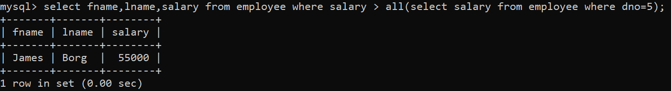

31. Display the names of employees, whose salary is greater than the average salary of all the employees in the

department 5.

**SYNTAX:**

**select fname,lname,salary from employee where salary > all(select salary from employee**

**where dno=5);**

**OUTPUT:**

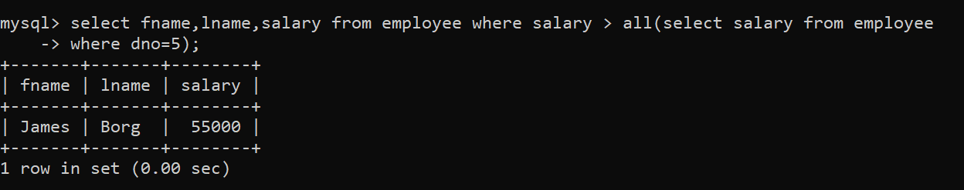

32. Display the list of all the employees who work in the same (project, hours) combination of employee whose

ssn=333445555.

**SYNTAX:**

**select distinct essn from works_on where (pno,hours) in (select pno,hours from works_on**

**where essn=333445555);**

**OUTPUT:**

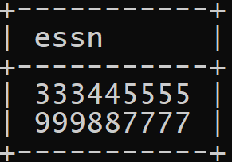

33. Retrieve all employees who were born during the 1950s.

**SYNTAX:**

**select fname, lname from employee where bdate like “__5_______”;**

**OUTPUT:**

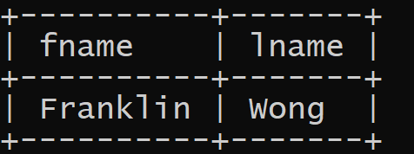

34. Retrieve the name and address of all employees who work for the 'Research' department using joins**.**

**SYNTAX:**

**select fname,lname from (Employee join Department on Dno=Dnumber)where**

**dname= “Research”;**

**OUTPUT:**

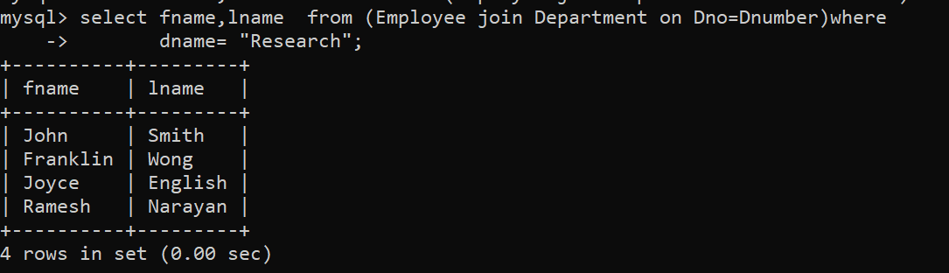

35. Retrieve the employee name and supervisor name of employee using outer join.

**SYNTAX:**

**select e.lname as employee_name, s.lname as supervisor_name from (employee as e left outer join**

**employee as s on e.superssn = s.ssn);**

**OUTPUT:**

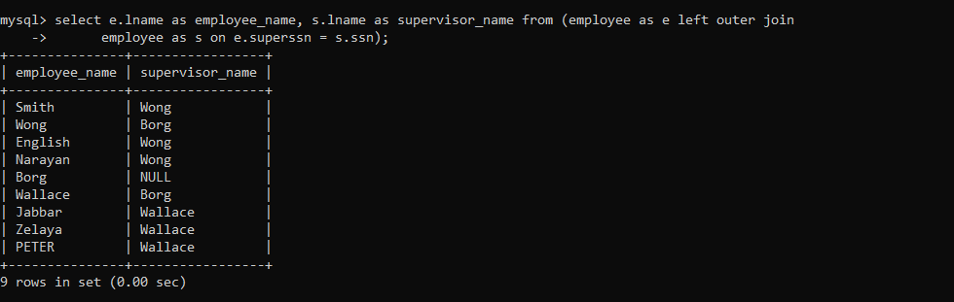

36. Retrieve the department name and employee first name - using inner join.

**SYNTAX:**

**select dno, fname from employee inner join department on employee.dno = department.dnumber;**

**OUTPUT:**

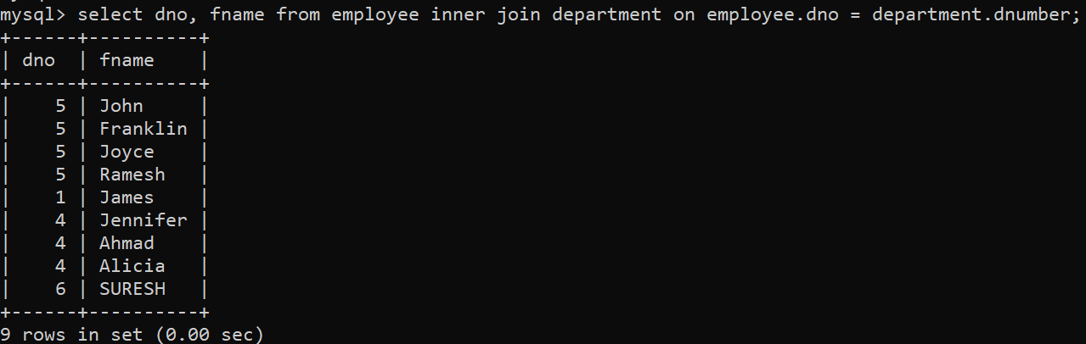

**Using LEFT JOIN:**

**SYNTAX:**

**select dno, fname from employee left join project on employee.dno = project.dnum;**

**OUTPUT:**

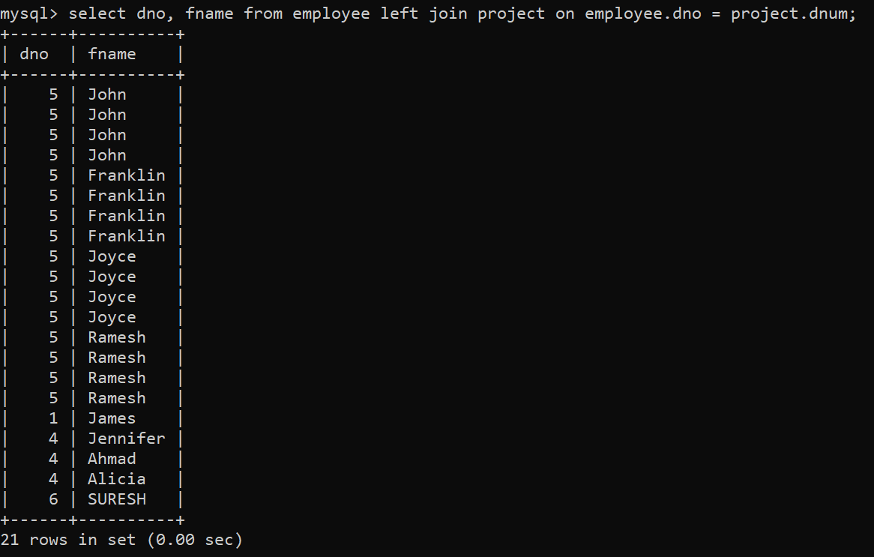

**Using RIGHT JOIN:**

**SYNTAX:**

**select dno, fname from employee right join project on employee.dno = project.dnum;**

**OUTPUT:**

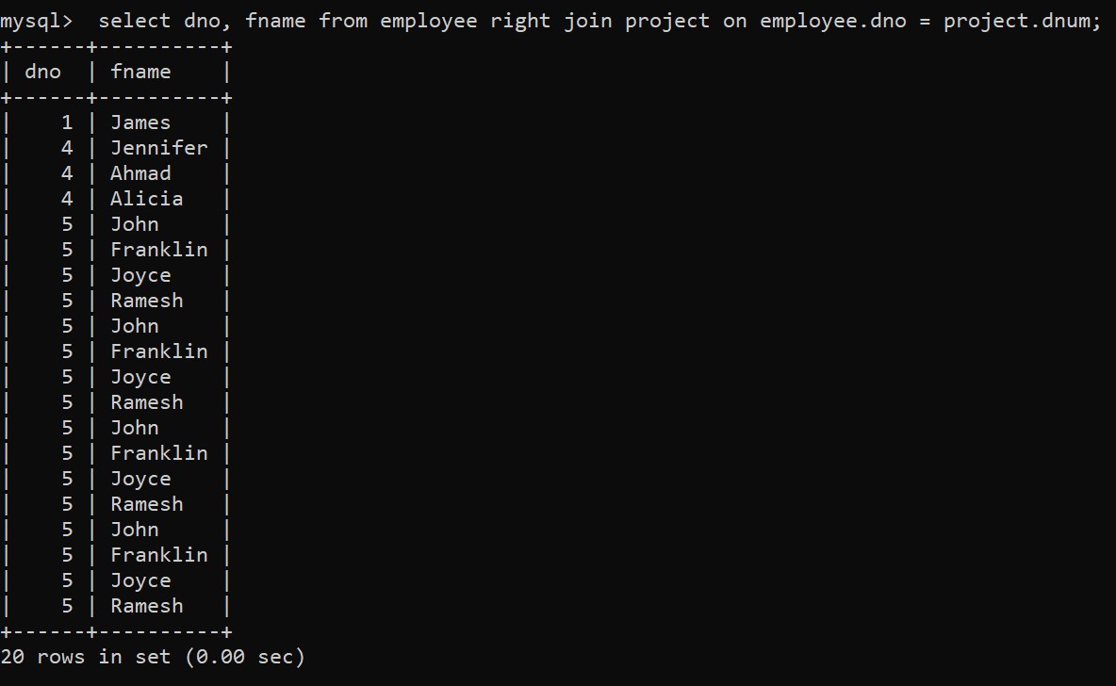

1,7,9,10,25,29

**UPDATE EMPLOYEE SET ADDRESS=CASE**

**SL_NO**

**WHEN 1 THEN “731-FONDREN-HOUSTON-TX”**

**WHEN 2 THEN “31-OXFORD-UK”**

**WHEN 3 THEN “HARVARD UNIVERSITY- MASSACHUSETTS”**

**WHEN 4 THEN “STANFORD UNIVERSITY- CALIFORNIA”**

**WHEN 5 THEN “UNIVERSITY OF CAMBRIDGE-UK”**

**WHEN 6 THEN “ETH ZURICH- SWITZERLAND”**

**WHEN 7 THEN “UNIVERSITY OF TOKYO-JAPAN”**

**WHEN 8 THEN “UNIVERSITY OF SYDNEY- AUSTRALIA”**

**WHEN 9 THEN “UNIVERSITY OF TORONTO-CANADA”**

**END**

**WHERE SL_NO IN(1,2,3,4,5,6,7,8,9,10);**